



КЕАҚ С.Ж. АСФЕНДИЯРОВ АТЫНДАҒЫ ҚАЗАҚ ҰЛТТЫҚ МЕДИЦИНА УНИВЕРСИТЕТІ
ФАРМАЦИЯ МЕКТЕБІ

НАО КАЗАХСКИЙ НАЦИОНАЛЬНЫЙ МЕДИЦИНСКИЙ УНИВЕРСИТЕТ им.С.Д.Асфендиярова
ШКОЛА ФАРМАЦИИ

NJTC S.ASFENDIYAROV KAZAKH NATIONAL MEDICAL UNIVERSITY
THE SCHOOL PHARMACY
INFORMATION MAIL
Dear colleagues!

We invite you to take part in the VI INTERNATIONAL SCIENTIFIC AND PRACTICAL CONFERENCE in memory of Professor R.D. Dilbarkhanov on the topic «FORMATION AND DEVELOPMENT PROSPECTS OF A SCIENTIFIC SCHOOL OF PHARMACY: CONTINUITY OF GENERATIONS»

Planned directions of the conference:
1. Organizational and economic issues of pharmaceutical activity and marketing research of the drug market.
2. Modern technologies, production of drugs of synthetic and natural origin and medical products.
3. Quality control and standardization of drugs
4. Pharmacognostic analysis of medicinal plant materials, standardization of herbal preparations.
5. Current issues in clinical pharmacy, pharmacology and clinical pharmacology.
6. Current state and prospects for the development of cosmeceuticals and cosmetology.
7. Modern biological/biotechnological drugs. Current development issues and prospects for use.
8. The concept of ensuring the quality of medicines and medical devices within the framework of GxP.

Date and place of the conference:
Date and time of the conference: hybrid (face-to-face and online Webex meet platform), June 28, 2024 10.00 a.m.
Venue of the conference: Almaty, st. Tole bi, 94, conference hall "Phytoteka".

Forms of participation in the conference:
- face-to-face (presentation and publication of an article/thesis);
- poster presentation and publication;
- correspondence (only publication of articles/abstracts).

Organizational fee - 3000 tenge.

KZ666010131000122045KZT  Кбе 18  БИК HSBKKZKX  БИН: 091040007937  РНН Банка 600 700 622275  АО «Народный Банк Казахстана»  КНП 859 |  | 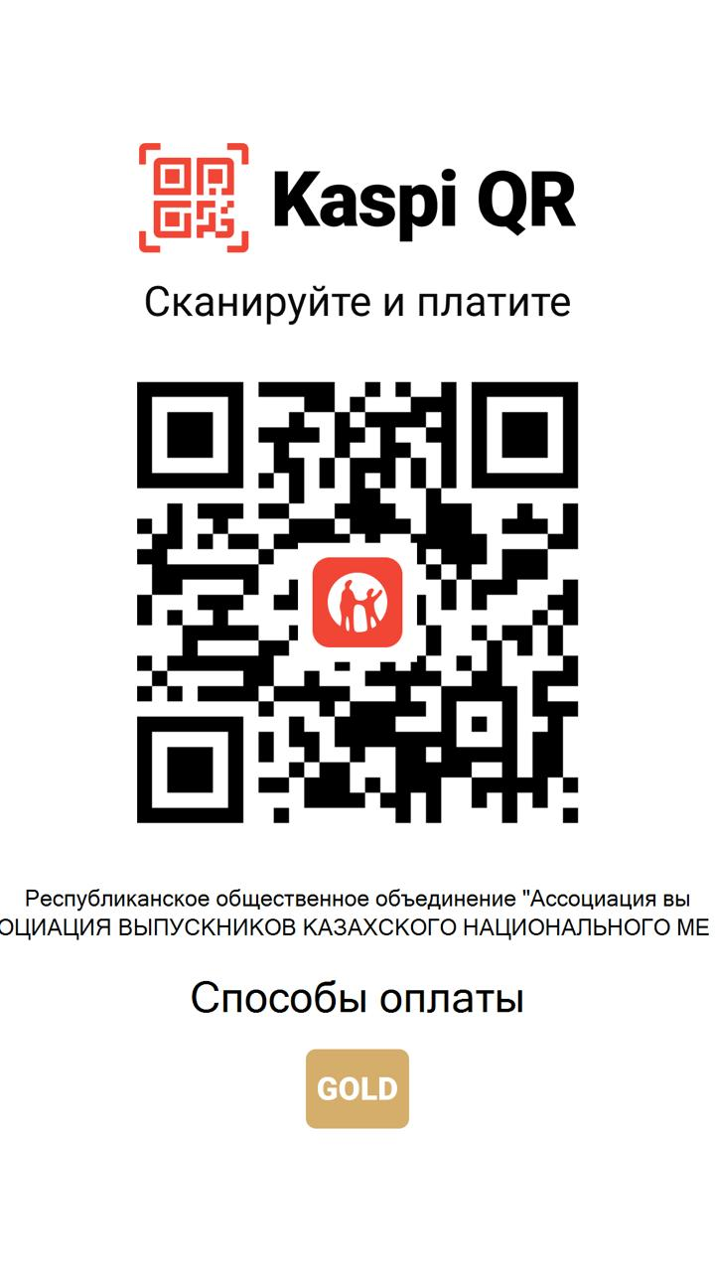

Travel expenses are paid by the sending party.
Deadline for submitting applications and articles.
Applications for participation in the conference and articles/abstracts are accepted electronically by email conference-pharm@mail.ru
Applications for participation in the conference and articles/abstracts for publication are submitted until June 17, 2024 (Appendix 1).

Articles/abstracts are presented in electronic version, saved in *doc format. One file must contain one article.
File names must correspond to the first author in Russian (full name.doc). If two articles of the same author are submitted, then the files are numbered in Arabic numerals (full name.1.doc). The application for participation is attached as a separate file (Full name.-application.doc or Full name1-application.doc).
The text of the article/abstract and the application for participation must be sent by email to the address: conference-pharm@mail.ru (when sending, indicate conference in the “subject” column). A message about receipt of the article/abstract will be sent to the email address you provided.
Travel is at the expense of conference participants. Those who wish are provided with accommodation in a dormitory.
The organizing committee reserves the right to reject materials if they do not correspond to the theme of the conference.
Materials not submitted in accordance with the requirements or submitted after the specified dates will not be accepted.
No more than two articles are accepted from one author.

Requirements for the design of publications: Вестник КазНМУ (Appendix 2)

https://kaznmu.kz/ https://kaznmu.edu.kz/rus/kak-razmestit-statju/

Contact number: +77023610145 – Alimova Urziya Sunnatullaevna

Best regards, Conference Organizing Committee

Annex 1

APPLICATION FOR PARTICIPATION IN THE CONFERENCE
(to be completed separately for each author!)

Full name
Date of birth
City, full name of univercity
Place of work or study
Job title
Academic degree, academic title
Contact number
E-mail
Participation form:
- face-to-face (report and publication)
- correspondence (publication only)
Direction of the conference
Title of the report (if desired)
Article title

(Appendix 2)
Journal Vestnik KazNMU

NOTE TO AUTHORS

We ask authors to adhere to international rules for constructing publications and summaries for them.

General provisions

1. Fully completed articles in electronic form are sent to the editor.
2. Name the file by the last name of the first author (Ivanov.doc or Ivanov1.doc, Ivanov2.doc).
3. The manuscript is accepted with a covering letter from the head of the institution (attached file) in which the work was carried out (except for KazNMU named after S.D. Asfendiyarov).
4. Expert opinion on the possibility of publication in the open press.
5. Brief information about the author(s) - last name, first name, patronymic (in full), position and place of work, E-mail, fax, telephone, address.
6. Submission to the editor of works published in other publications or sent to other editors is not allowed.
7. Articles prepared by the authors not in accordance with these requirements will be returned without consideration.
8. The editors have the right to shorten articles and, if necessary, make amendments to them.
9. All articles are peer reviewed
10. Preparation of the article

Articles are accepted in Russian, Kazakh or English.

Article in format: A4 -212x297 mm, all margins 20 mm, page number in the upper right corner; 1 interval, font size - 14 pt, indent 10 mm, typesetting format - WORD document 6, 7 or 8 versions, or *.rtf. Use Times New Roman font only.

A summary of 7-8 lines (up to 1000 words) in Russian (if the article is in Russian) is placed before the text, and in Kazakh and English - at the end of the article. Accordingly, a summary in Kazakh is placed at the beginning of the article in Kazakh, and in Russian and English - at the end of the article text. Each abstract must contain a title, authors' names and keywords.

Volume of articles: regular - up to 10 pages, lectures - up to 12, review - up to 14 pages.

Figures and tables are drawn up in accordance with the requirements for the design of dissertation works of the KKSON MES RK. Illustrative material (photographs) is presented on separate sheets with the order and location of their location in the article indicated in the margins.

Authors must retain copies of all submitted material.

Title part

1. The title of the article, which should be short (no more than 10 words), but informative;
2. Initials and surname of each author;
3. Name of the institution, department, department, laboratory in which the work was performed.

Authorship

All persons designated as "authors" must meet the criteria for this concept. The participation of each "author" in the work must be sufficient to take upon himself
responsibility to the public for its content. Eligibility to be an author should be based only on significant contributions to: a) the concept or research design or analysis,
data interpretation; b) writing a version, initial preparation of the article, or critical analysis of it in order to introduce important intellectual content; c) on approval of the final version, which is submitted for printing. Any part of the paper that is critical to its main conclusions should be the responsibility of at least one of the authors.

Summary and keywords

A summary of approximately 1000 words and keywords (no more than 6) must be submitted to
English, Russian and Kazakh languages. The abstract, after the title and authors of the article, should briefly outline the objectives of the study, the main procedures (selection of study subjects, methods) and the main conclusions. Highlight new and important aspects of the study or observation.

Under the summary after the “Keywords” designation, place from 3 to 6 words or short phrases in the same language, which will contribute to the correct cross-indexing of the article.

Text

The text of an article containing the results of original research (observations or experiments) is usually, but not necessarily, divided into sections:

• Introduction (indicating the purpose of the study)
• Materials and methods
• Results
• Discussion and conclusion
• Conclusions are desirable.

Some types of articles (clinical observations, reviews, problem articles) may be formatted differently.

In the introduction, state the purpose of the work. Justify the relevance of the study or observation. Mention only works that are strictly related to the topic.

In the Materials and Methods section, describe how patients or animals were selected, including control groups. Describe the equipment (manufacturer and country of production). There are enough references to generally accepted research methods; for those published but not widely known - a brief description; describe new or significantly modified methods, provide a rationale for their use, and an assessment of their limitations. Mathematical formulas, substance content standards, maximum permissible concentrations, all drugs and chemicals used: generic and commercial name (manufacturer), doses, methods of use, routes of administration, etc.

Print tables after the reference to the table in the text, title each column, and provide an explanation of terms and abbreviations in the notes to the table. Drawings must be made on a computer. Place it at the bottom of the picture number, title, if necessary, indicate the top and bottom of the picture. Microphotographs must have internal scale marks.

Chemical formulas, doses, mathematical formulas must be carefully verified and endorsed by the author in the margins.

Abbreviations of words and terms are deciphered at the first mention in the text.

Links, bibliography

Number the references in the order they appear in the text. Indicate all references using Arabic numerals in square brackets ([ ]). The names of foreign authors are given in the original transcription.

Registration of the list of references: Last name and initials. Title of work //Name of source. -Imprint (for example: Hygiene and Sanitation. - 1998.-No. 5.-P. 15-20).

Press service address:

Almaty, Tole-bi 94, Kazakh National Medical University, Rectorate, office 225.

